Installation

#### boto3 :

Install the latest Boto 3 release via **pip**:  
**pip install boto3**

Configuration for boto3:

If you have the AWS CLI installed, then you can use it to configure your credentials file (if not then install aws cli using **pip3 install --upgrade awscli** ):

**aws configure**

**[default]  
aws_access_key_id = YOUR_ACCESS_KEY  
aws_secret_access_key = YOUR_SECRET_KEY**

**[default]  
region= region -- e.g. us-east-1**

Kindly provide aws_access_key_id and aws_secret_access_key. Because of security reasons I am not attaching id and secret key in mail.

Flask :

pip3 install Flask

Used S3 bucket :

emp-face-recognition-demo

Used dynamoDB table :

Employee_collection

Request & Response:

**Registration**:

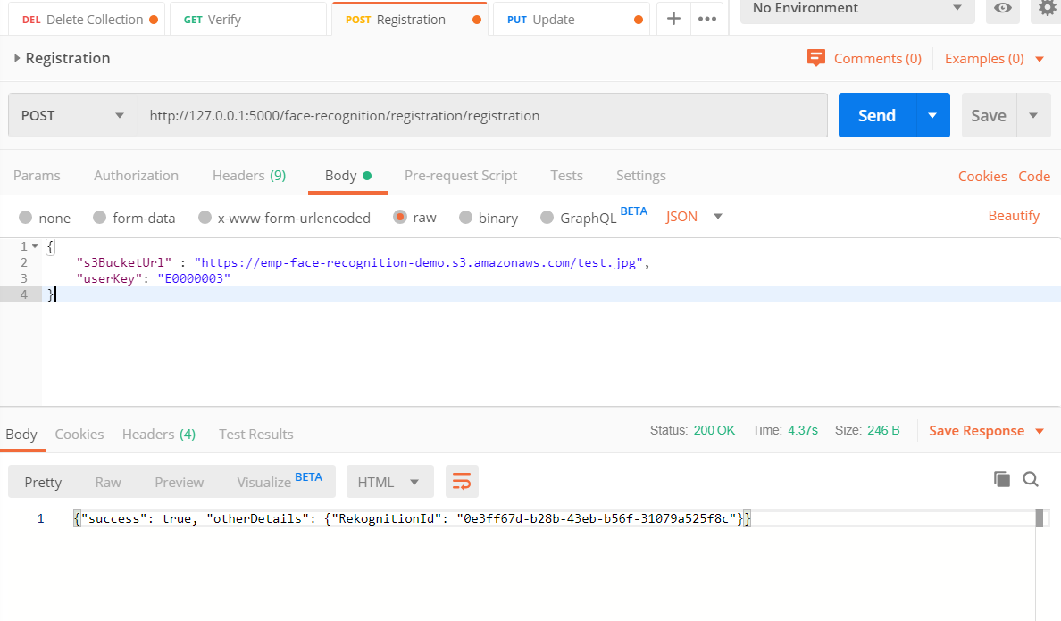

**Verify :**

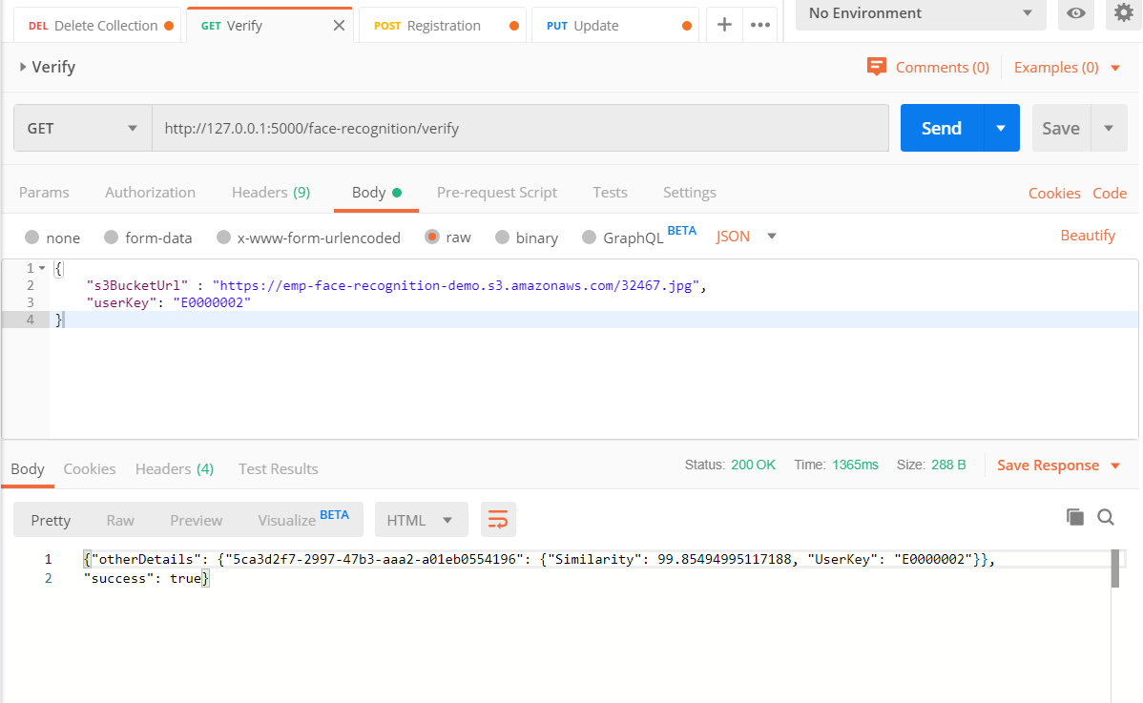

**Update:**

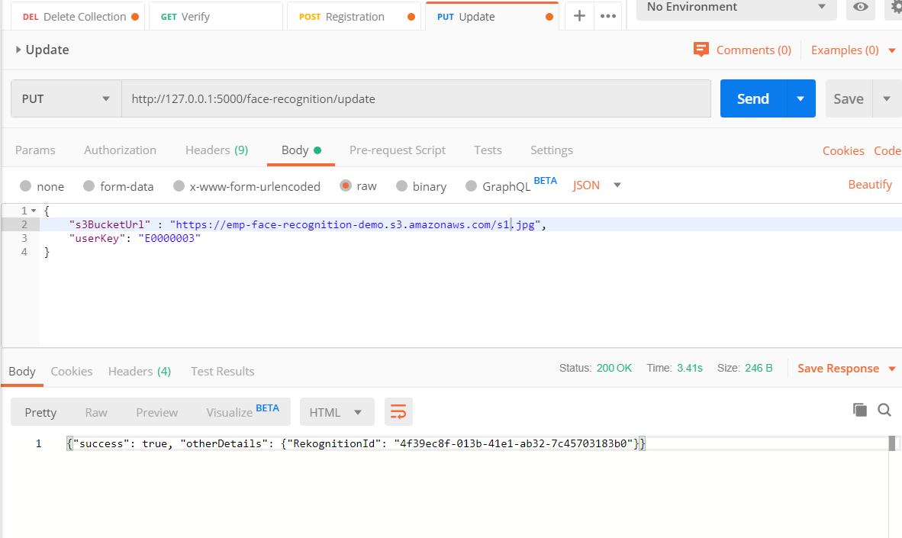

**Delete:**

